Decision record: USFS special uses prototype scope

| **Status** | **Decided** |
| --- | --- |
| **Initial drafter** | [Alia Salim - Q2ADAACB](mailto:alia.salim@gsa.gov) |
| **Approvals** | [Neil Martinsen-Burrell - Q2ADAAAC](mailto:neil.martinsen-burrell@gsa.gov)[Dave Luetger - Q2ADAACF](mailto:david.luetger@gsa.gov) |

# Summary

In order to move forward with work on a digital permitting prototype for USFS Special Uses, we need to define the scope of that prototype. Exactly what type of users should it serve? What exactly should it help those users do?

# Context

* [This Github ticket](https://github.com/18F/usfs-special-uses-prototype/issues/55) represents this decision on our project board.
* [This Mural diagram](https://app.mural.co/t/gsa6/m/gsa6/1723218133366/fc598453fc3f3260b9c9712fcc905fcbe6880ce1?sender=u9ac43edf54de743b3d9b2405) shows a hypothetical user journey for a permit-seeker. The proposed scope for an initial prototype is represented as a red box around a portion of that user journey.
* [USFS Special Uses Running Notes](https://docs.google.com/document/d/1uCe4Bx91J-0dRt1lWi4a1NCVCMnOcJsu93q4otYNy7E/edit#heading=h.f8lln48llbz3) captures a related discussion between [Neil Martinsen-Burrell - Q2ADAAAC](mailto:neil.martinsen-burrell@gsa.gov) and [Alia Salim - Q2ADAACB](mailto:alia.salim@gsa.gov)
* [RECOMMENDATIONS report](https://docs.google.com/document/d/1VGbWeluqdELUvy59HoDxe9I3WdNkpNDfgYiLOz_eUJQ/edit) includes initial 18F recommendations regarding the prototype.

# Assumptions

* Our initial prototype is intended as a starting point for future expansion, for example, to serve additional user types or user needs.
* It’s likely that USFS will soon assign a product owner to this work. That product owner will guide future decision-making—for example, how to prioritize work that follows completion of an initial prototype.
* It’s likely that certain funding may be available to USFS to support work focused on broadband, specifically, as opposed to other special uses or all special uses.

# Drivers

A decision needs to be made because certain design and content work cannot continue efficiently without a clear definition of scope for the prototype.

A decision needs to be made now because our current engagement is likely to end in early October, limiting the time available to work on a prototype.

# Options

## Proposed scope

We propose to design our initial prototype specifically for a user applying for a special-use permit in broadband/communications. The prototype will meet the user at the point in the process they would otherwise fill out SF-299, and/or the broadband intake form.

[This Mural diagram](https://app.mural.co/t/gsa6/m/gsa6/1723218133366/fc598453fc3f3260b9c9712fcc905fcbe6880ce1?sender=u9ac43edf54de743b3d9b2405) shows a hypothetical user journey for a permit-seeker. The proposed scope for an initial prototype is represented as a red box around a portion of that user journey.

[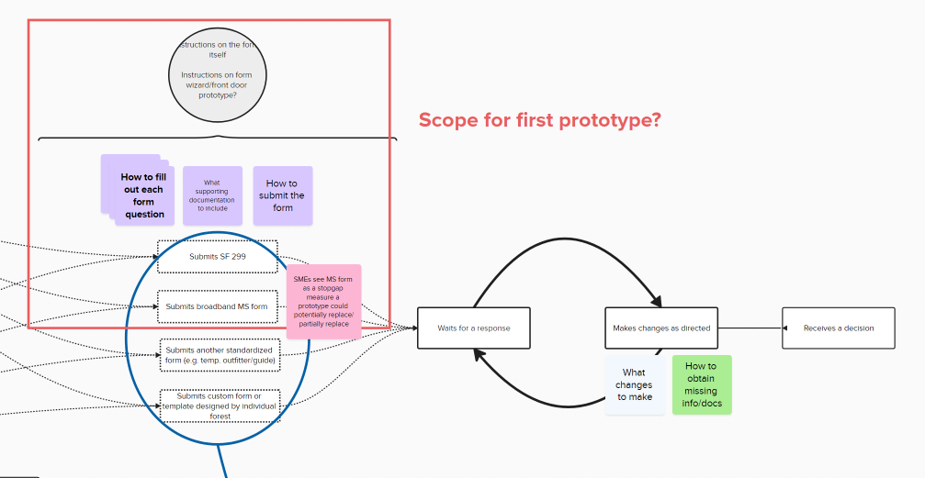](https://app.mural.co/t/gsa6/m/gsa6/1723218133366/fc598453fc3f3260b9c9712fcc905fcbe6880ce1?sender=u9ac43edf54de743b3d9b2405)

### Rationale

* The existing [broadband submission form](https://forms.office.com/pages/responsepage.aspx?id=5zZb7e4BvE6GfuA8-g1Gl7wOtc5OGxpLpF1r-Go-o_5UOVlVQUxCTVMyRzRLVU9WN042UEEzTFg4NiQlQCN0PWcu) has already set a precedent as a centralized starting point for broadband permit-seekers. A prototype could potentially replace this form.
* It’s likely that certain funding may be available to USFS to support work focused on broadband, specifically, as opposed to other special uses or all special uses.
* SF-299 is more relevant to broadband/communication uses than to other types of special uses, which may limit the amount of “translation” the initial prototype needs to provide to the user.

### Risks and mitigations

If the proposed scope is too narrow, it may not serve as an effective proof of concept for future work. We could mitigate this risk by:

* Clearly communicating the purpose of the prototype.
* Working with a USFS product owner to develop a roadmap for future work.

If the proposed scope is too broad, it may not be feasible to complete a prototype in the time remaining for the engagement. We could mitigate this risk by:

* Working iteratively, rather than waiting to complete all research and discovery before beginning design.
* Working with a USFS product owner to develop a roadmap for future work.

## Alternatives

* A prototype could address a user need earlier in the journey: for example, the need for a permit-seeker to correctly identify the forest or district where the permitted activity would occur.
* A prototype could address a user need later in the journey: for example, the need for a permit-seeker to know the status of their proposal after it has been submitted.
* A prototype could address a different type of user: for example, a permit-seeker who wants to operate as an outfitter/guide.

# Method and stakeholders

## Method

We solicited feedback on this proposal in a meeting (August 20, 2024) with USFS SMEs [travis.fack@usda.gov](mailto:travis.fack@usda.gov), Jennifer Whyte, and Amanda Noyes.

[Alia Salim - Q2ADAACB](mailto:alia.salim@gsa.gov) walked through the [permit-seeker user journey Mural](https://app.mural.co/t/gsa6/m/gsa6/1723218133366/fc598453fc3f3260b9c9712fcc905fcbe6880ce1?sender=u9ac43edf54de743b3d9b2405) and the proposed area of focus for an initial prototype. USFS SMEs:

* Stated that they could envision both the proposed prototype and various alternatives that addresses user needs earlier in the journey: “either could work.”
* Agreed that funding available for broadband, specifically, is a factor in deciding the scope of the initial prototype.
* Clarified that the initial prototype could be imagined as a replacement for (rather than complement to) the [broadband submission form](https://forms.office.com/pages/responsepage.aspx?id=5zZb7e4BvE6GfuA8-g1Gl7wOtc5OGxpLpF1r-Go-o_5UOVlVQUxCTVMyRzRLVU9WN042UEEzTFg4NiQlQCN0PWcu), which they describe as a “stopgap” measure.

## Stakeholders

See [USFS Special Uses Team Charter](https://docs.google.com/document/d/1w83VWeldgRBuOWVN9ckbMdUZiNo6w5Xdjk7lGyYQ1BY/edit#heading=h.2fipw7425obn) for a list of stakeholders.

# Conclusion and implementation

We decided to move forward with the proposed scope for an initial prototype, as described above. We will begin to implement this decision by writing user stories within the scope of the prototype.